Hospital Patient Record System - Project Report

1. Introduction
This project, titled "Hospital Patient Record System", is developed using Flask and MySQL.
It is designed to help hospital staff manage patient data, schedule appointments, and view appointment records efficiently.
It supports adding new patients, storing their medical information, and associating them with appointments scheduled with doctors on specific dates.

2. Tools & Technologies Used
- Frontend: HTML5, CSS3 (Bootstrap 5)
- Backend: Python (Flask Framework)
- Database: MySQL
- IDE: Visual Studio Code
- Other Tools: MySQL Workbench, Browser (Edge/Chrome)

3. Modules Implemented
- View All Patients: Displays a table of all registered patients.
- View Appointments: Shows a list of scheduled appointments with patient name, doctor, date, and reason.
- Add New Patient: Allows the admin to register a new patient.
- Schedule Appointment: Enables appointment booking between a patient and a doctor.

4. Application Screenshots

Homepage
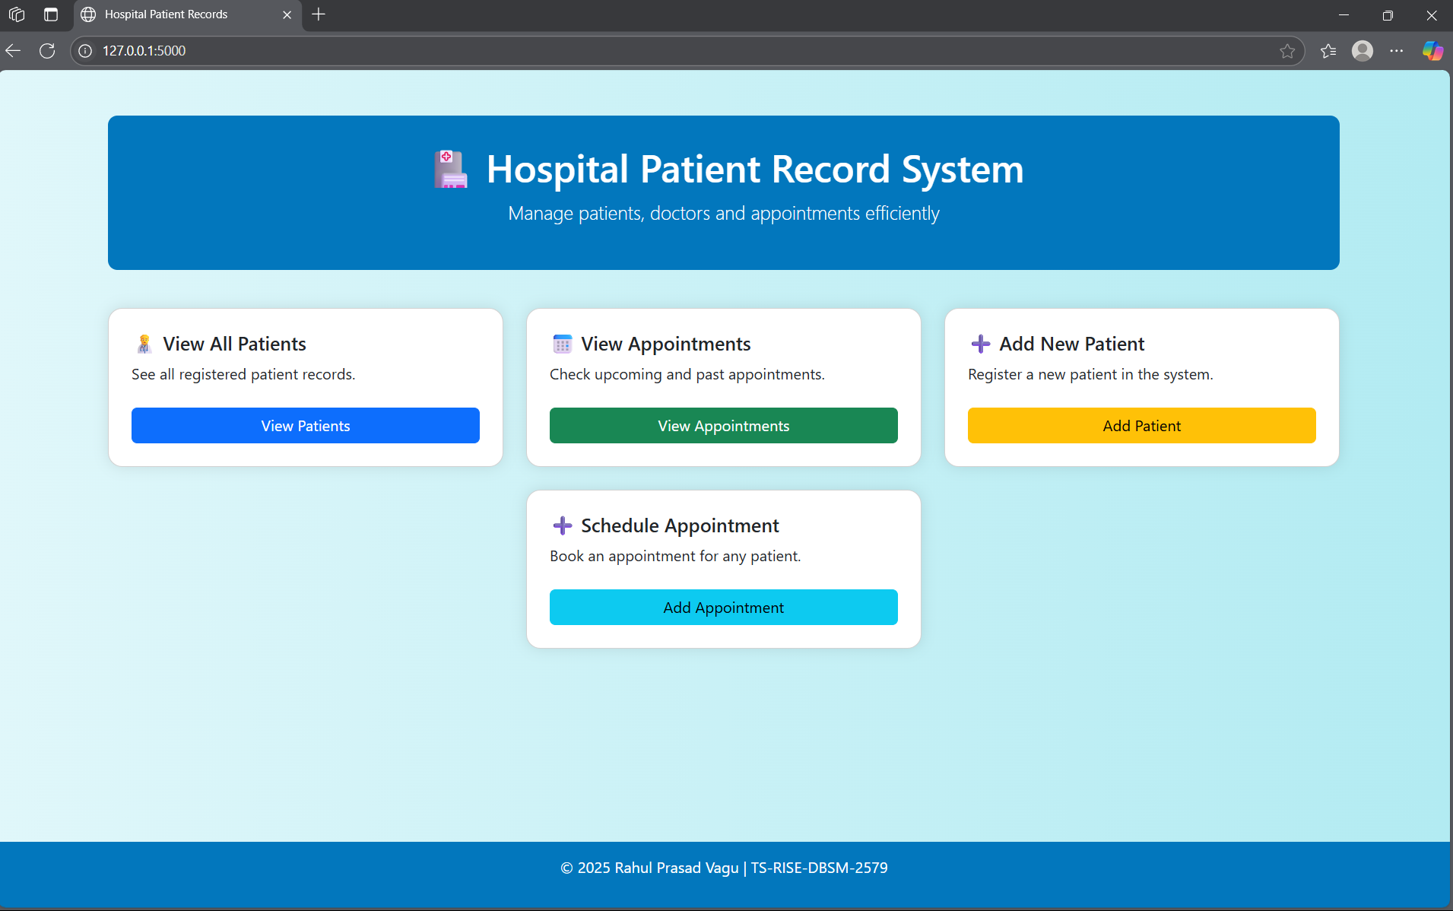
Screenshot: Homepage

Patients List
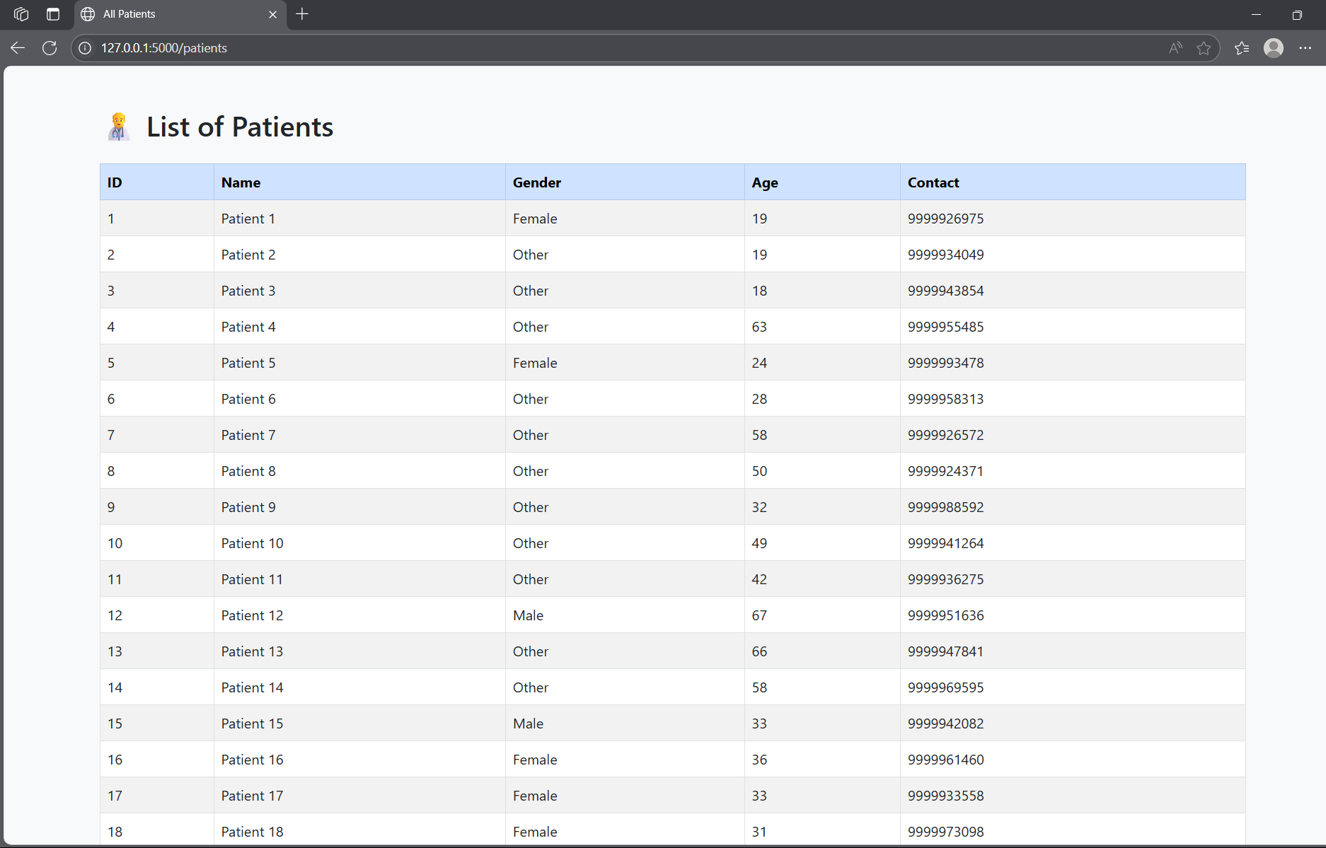
Screenshot: Patients List

Appointments List
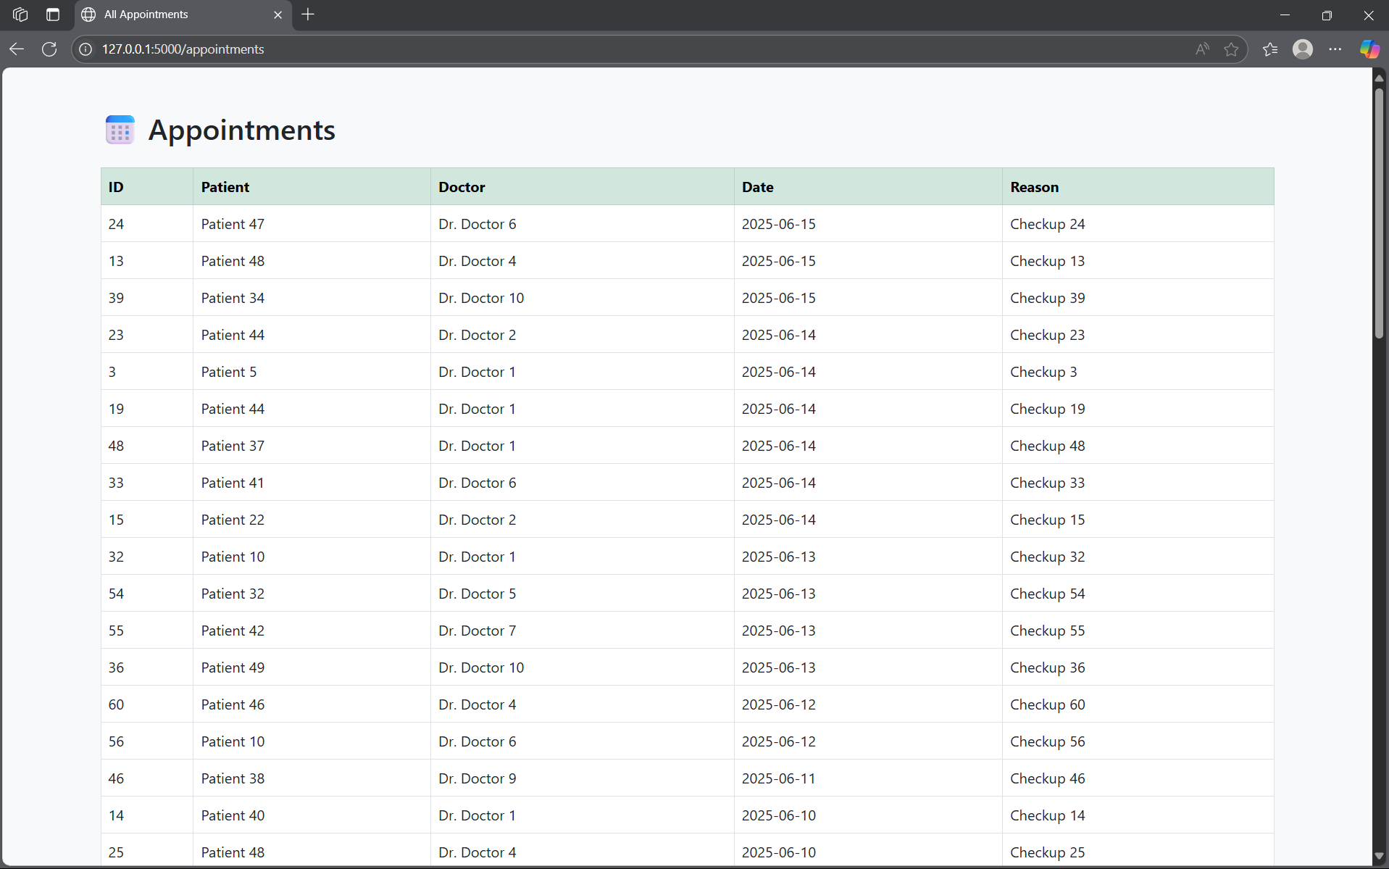
Screenshot: Appointments List

Add New Patient
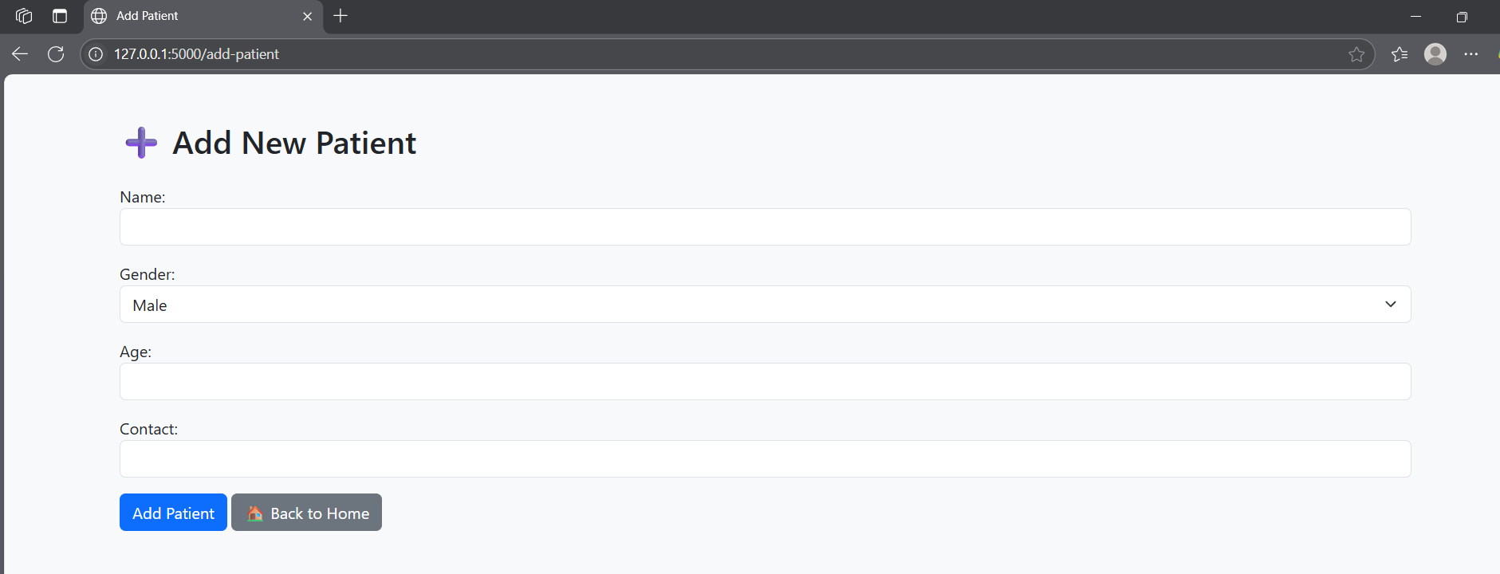
Screenshot: Add New Patient

Add Appointment
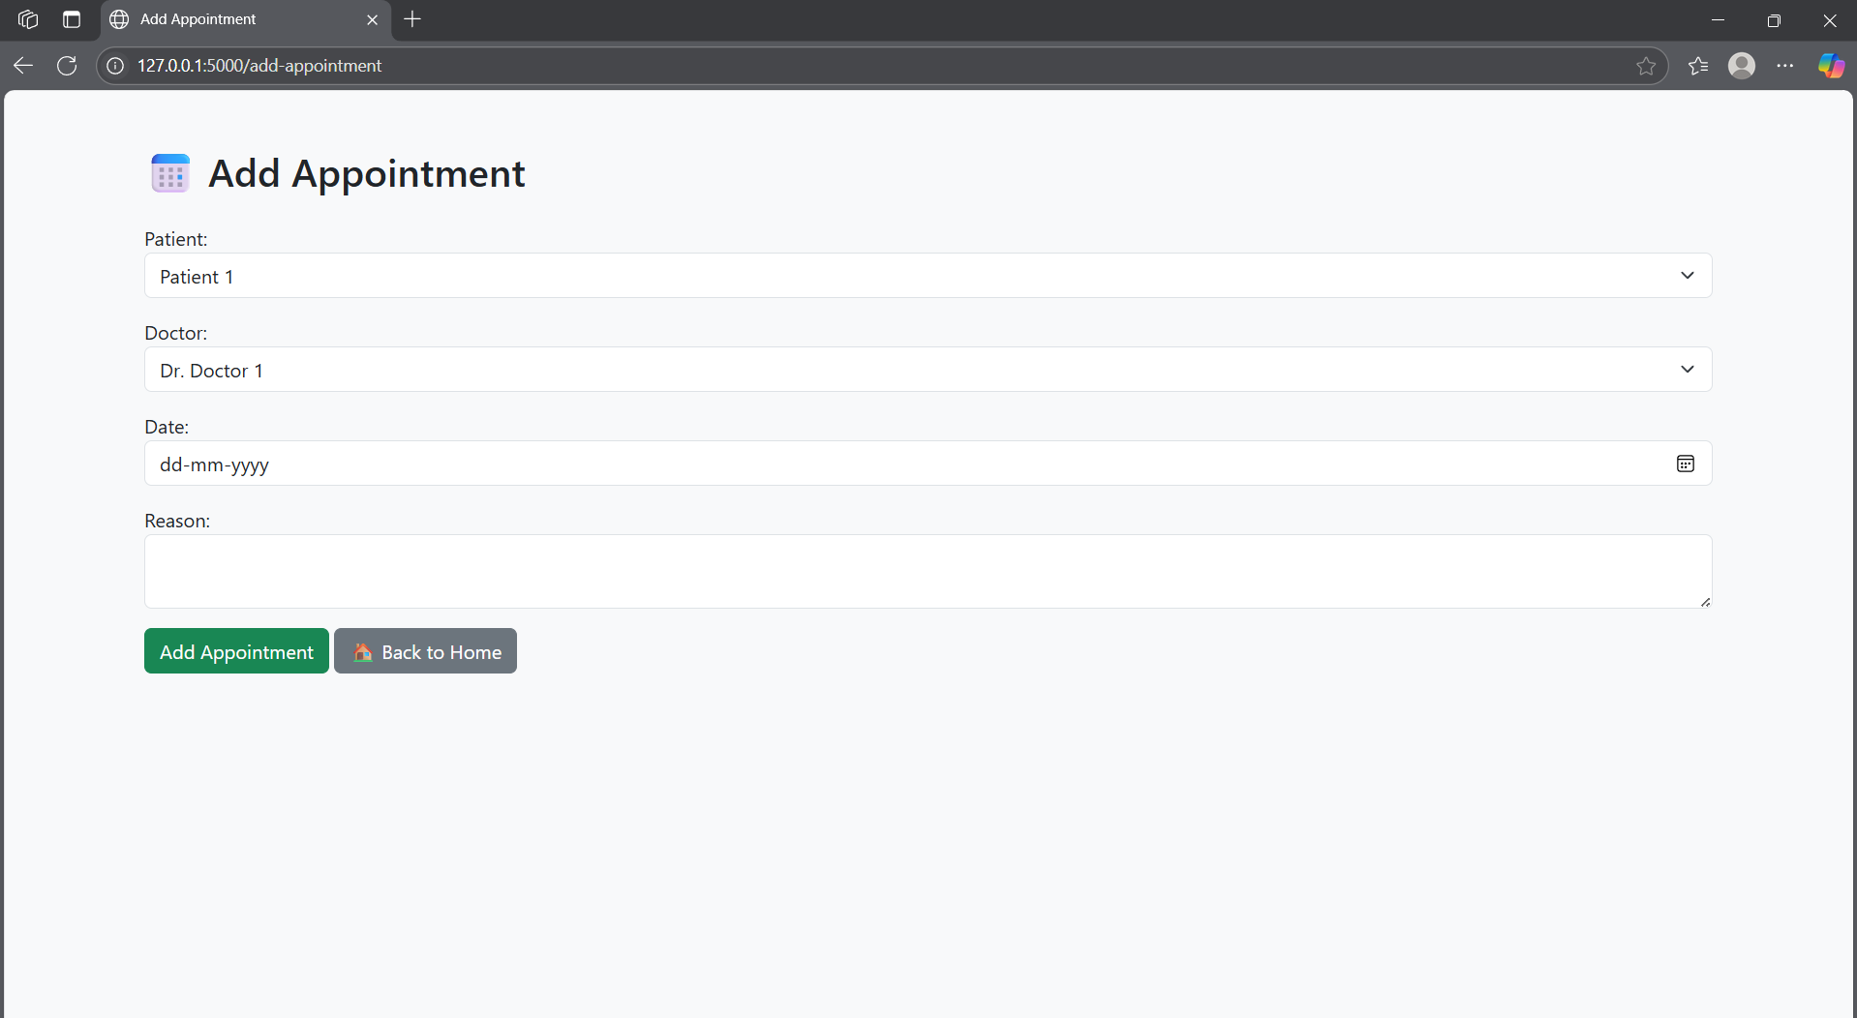
Screenshot: Add Appointment

Code View (app.py)
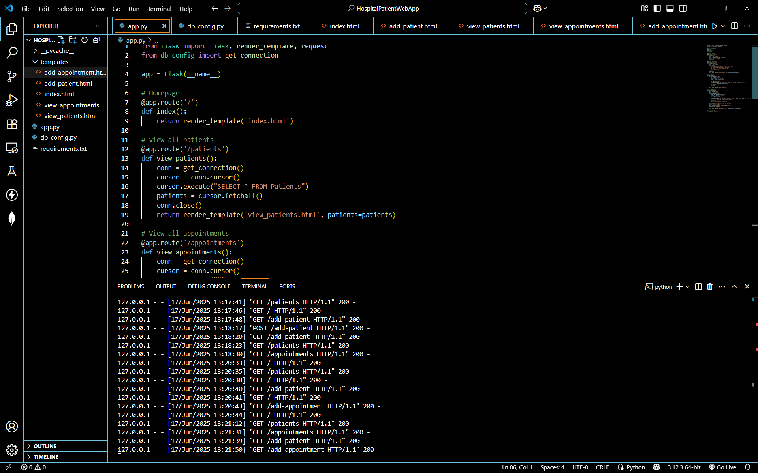
Screenshot: Code View (app.py)

5. Conclusion
This project successfully implements a basic hospital management backend system.
It efficiently demonstrates CRUD operations, relational database integration, and Flask-based routing and rendering.
Further enhancements may include admin authentication, reports download, and role-based access.

